**上机实践5：子类与继承**

**一、实验目的**

1. 掌握子类的继承性。
2. 掌握方法的继承与重写，super关键字的使用。
3. 掌握上转型对象的使用。

**二、实验内容及步骤**

**实验1 中国人、北京人、美国人 编写程序模拟中国人、美国人是人、北京人是中国人。掌握子类对象的创建，成员变量的继承与隐藏，方法的继承与重写。**

程序：

**package** example1;

**public** **class** People {

**protected** **double** weight,height;

**public** **void** speakHello(){

System.***out***.println("yayayaya");

}

**public** **void** averageHeight(){

height=173;

System.***out***.println("average height:"+height);

}

**public** **void** averageWeight(){

weight =70;

System.***out***.println("average weight:"+weight);

}

}

**package** example1;

**public** **class** ChinaPeople **extends** People {

@Override

**public** **void** speakHello() {

System.***out***.println("您好");

}

@Override

**public** **void** averageHeight() {

height = 168.78;

System.***out***.println("中国人的平均身高："+height+"厘米");

}

@Override

**public** **void** averageWeight() {

weight = 68;

System.***out***.println("中国人的平均体重:"+65+"千克");

}

**public** **void** chinaGongfu(){

System.***out***.println("坐如钟，站如松，睡如弓");

}

}

**package** example1;

**public** **class** BeijingPeople **extends** ChinaPeople {

@Override

**public** **void** averageHeight() {

// **TODO** Auto-generated method stub

height=172.5;

System.***out***.println("北京人的平均身高："+height+"厘米");

}

@Override

**public** **void** averageWeight() {

// **TODO** Auto-generated method stub

weight = 75;

System.***out***.println("北京人的平均体重:"+weight+"kg");

}

**public** **void** beijingOpera(){

System.***out***.println("花脸，青衣，花旦和老生");

}

}

**package** example1;

**public** **class** AmericanPeople **extends** People {

@Override

**public** **void** speakHello() {

// **TODO** Auto-generated method stub

System.***out***.println("How do you do");

}

@Override

**public** **void** averageHeight() {

// **TODO** Auto-generated method stub

height=176;

System.***out***.println("American's average height:"+height+" cm");

}

@Override

**public** **void** averageWeight() {

weight=75;

System.***out***.println("American's average weight:"+weight +"kg");

}

**public** **void** americanBoxing(){

System.***out***.println("直拳，勾拳，组合拳");

}

}

**package** example1;

**public** **class** Example {

**public** **static** **void** main(String[] args) {

// **TODO** Auto-generated method stub

ChinaPeople chinaPeople = **new** ChinaPeople();

AmericanPeople americanPeople = **new** AmericanPeople();

BeijingPeople beijingPeople = **new** BeijingPeople();

chinaPeople.speakHello();

americanPeople.speakHello();

beijingPeople.speakHello();

americanPeople.averageHeight();

beijingPeople.averageHeight();

chinaPeople.averageHeight();

chinaPeople.averageWeight();

beijingPeople.averageWeight();

americanPeople.averageWeight();

chinaPeople.chinaGongfu();

americanPeople.americanBoxing();

beijingPeople.beijingOpera();

beijingPeople.chinaGongfu();

}

}

运行截图：

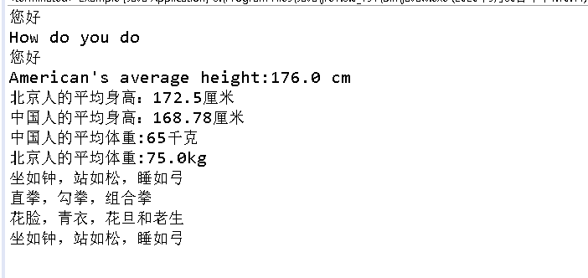

**实验2 银行计算利息 假设银行Bank已有按整年year计算利息的一般方法，其中year只能取正整数。建设银行重写计算利息的方法，可计算实数的利息。**

程序：

**package** example2;

**public** **class** Bank {

**int** saveMoney;

**int** year;

**double** interest;

**double** interestRate = 0.29;

**public** **double** computerInterest(){

interest = year * interestRate *saveMoney;

**return** interest;

}

**public** **void** setInterestRate(**double** rate){

interestRate = rate;

}

}

**package** example2;

**public** **class** BankOfDalian **extends** Bank {

**double** year;

@Override

**public** **double** computerInterest() {

**super**.year = (**int**)year;

**double** r= year -(**int**)year;

**int** day = (**int**)(r*1000);

**double** yearInterest = **super**.computerInterest();

**double** dayInterest = day*0.00012*saveMoney;

interest = yearInterest + dayInterest;

System.***out***.printf("%d 元存在大连银行%d年零%d天的利息：%f元\n",saveMoney,**super**.year,day,interest);

**return** interest;

}

}

**package** example2;

**public** **class** ConstructionBank **extends** Bank{

**double** year;

@Override

**public** **double** computerInterest() {

**super**.year = (**int**)year;

**double** r = year-(**int**)year;

**int** day = (**int**)(r*1000);

**double** yearInterest = **super**.computerInterest();

**double** dayInterest = day *0.0001*saveMoney;

interest = yearInterest +dayInterest;

System.***out***.printf("%d 元存在建设银行%d年零%d天的利息：%f元\n",saveMoney,**super**.year,day,interest);

**return** interest;

}

}

**package** example2;

**public** **class** SaveMoney {

**public** **static** **void** main(String[] args) {

**int** amount=8000;

ConstructionBank bank1 = **new** ConstructionBank();

bank1.saveMoney = amount;

bank1.year = 8.236;

bank1.setInterestRate(0.035);

**double** intrest1 = bank1.computerInterest();

BankOfDalian bank2 = **new** BankOfDalian();

bank2.saveMoney = amount;

bank2.year = 8.236;

bank2.setInterestRate(0.035);

**double** interest2 = bank2.computerInterest();

System.***out***.printf("两个银行利息相差%f元\n",interest2-intrest1);

}

}

运行截图：

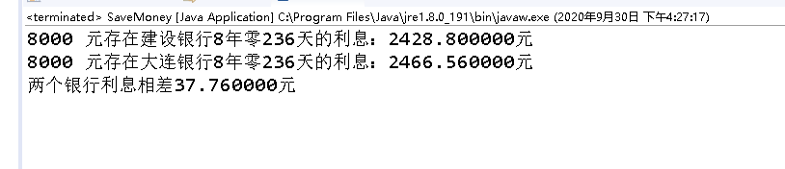

**实验3 公司支出的总薪水 公司里有按年、按月和按星期支付薪水的员工，现统计公司一年需要支付的薪水总额。掌握上转型对象的使用，即继承的多态性。**

程序：

**package** example3;

**public** **class** Company {

Employee [] employees;

**double** salaries = 0;

**public** Company(Employee[] employee) {

// **TODO** Auto-generated constructor stub

**this**.employees = employee;

}

**public** **double** salariesPay(){

salaries = 0;

**for**(**int** i =0;i<employees.length;i++){

salaries = salaries +employees[i].earnings();

}

**return** salaries;

}

}

**package** example3;

**public** **class** CompanySalary {

**public** **static** **void** main(String[] args) {

Employee [] employee = **new** Employee[29];

**for**(**int** i=0;i<employee.length;i++){

**if**(i%3==0)

employee[i] = **new** WeekWorker();

**else** **if** (1%3==1)

employee[i] = **new** MonthWorker();

**else** **if**(i%3==2)

employee[i] = **new** YearWorker();

}

Company company = **new** Company(employee);

System.***out***.println("公司薪水总额:"+company.salariesPay()+"元");

}

}

**package** example3;

**public** **abstract** **class** Employee {

**public** **abstract** **double** earnings();

}

**package** example3;

**public** **class** MonthWorker **extends** Employee {

@Override

**public** **double** earnings() {

// **TODO** Auto-generated method stub

**return** 12*2300;

}

}

**package** example3;

**public** **class** WeekWorker **extends** Employee {

@Override

**public** **double** earnings() {

// **TODO** Auto-generated method stub

**return** 52*780;

}

}

**package** example3;

**public** **class** YearWorker **extends** Employee {

@Override

**public** **double** earnings() {

// **TODO** Auto-generated method stub

**return** 12000;

}

}

运行截图：

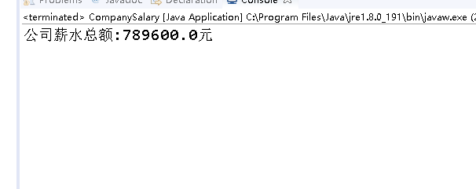

**三、实验小结**

掌握了子类的继承性。

掌握了方法的继承与重写，super关键字的使用。

掌握了上转型对象的使用。